**Write an algorithm for Online bus reservation system.**

**Step 1:** Start

**Step 2:** Create a registration page and login page.

**Step 3:** After login with admin credentialscreate an admin page with three options for pages bus details,customer details and driver & cleaner details.

**Step 4:** In the bus details page it has the list of bus id with details and delete,update,view,fare and add separate option to add new bus details.

**Step 5:** In the customer details page it has the list of customer id with details and delete,update,view and add separate option to add new customer details.

**Step 6:** In the driver & cleaner details page it has the list of driver id with details and delete,update,view and add separate option to add new driver details

**Step 7:** After login with user credentials create a user page with source,destination drop down with location.

**Step 8:** Under that date selection button and separate option for recent history.

**Step 9:** After this page the bus listing page with the source,destination and date given by the user.

**Step 10:** After selecting the bus from that page it will display the details of travel route,time,reviews and book ticket option.

**Step 11:** After selecting the book ticket option it displays the payment option upi and card.

**Step 12:** After booking a ticket it displays the review page to get review for the app and also for the bus travel after the user completed the travel.

**Step 13:** In selection of recent history in the home page it displays the recent booked tickets.

**Step 14:** Stop.

**Alternate algorithm:**

**For Admin.**

**Step :1** Start.

**Step :2** Open the application.

**Step :3** Admin can add the bus by creating an individual ID for each bus.

**Step :4** In Add bus, admin can add Bus [reg.no](http://reg.no),Bus type(ac/non ac),Operator name.

**Step :5** Admin can view the bus details by clicking the view button.

**Step :6** Admin can Update the details of the particular bus by entering its individual ID. **Step :7** Admin can Delete the bus by clicking the delete button.

**Step :8** Admin can add the ticket fare for the bus by using the individual Id

**Step: 9** Admin can Update/delete the ticket fare based on the route that bus is running. **Step: 10** Admin can view the booked customers details by using the ticket number.

**Step :11** Admin can approve the ticket cancellation if it's valid(before the specified time). **Step: 12** Admin can send the details of the booked customers to the driver of the bus. **Step: 13** Admin can send the details like bus [reg.no](http://reg.no),driver name,live tracking to the booked customer’s phone number.

**Step: 14** Stop.

**For Users.**

**Step :1** Start.

**Step :2** Open the application.

**Step :3** If the account already exists,go to step:5 else continue.

**Step :4** By clicking Sign Up, create an account by entering the mobile number.

**Step :5** Login with the username & password.If its valid continue,if not return to step:3

**Step :6** By clicking the search bar search the bus by entering the destination

**Step :7** Then click on the preferable bus and check for ticket fare and seat availability. **Step :8** If the preferable seat is available Select the seat and move to the payment process,If not return to step:6.

**Step :9** Select the preferable payment method and pay the ticket fare.

**Step :10** If the payment successful continue,if not return to step :8

**Step :1**1 Now,download the ticket by clicking the download button.

**Step :12** If needed,the user can cancel the ticket before the specified time.

**Step :13** User can check the bus details,and driver details on the day of travel,it will be sent by admin.

**Step :14** After the journey ,users can give a review of their travel by rating stars and writing their review as a comment.

**Step :15** Stop.

| **Problem Statement:Online Bus Reservation System** | | | | | | | | | | |
| --- | --- | --- | --- | --- | --- | --- | --- | --- | --- | --- |
|  | | | | |  |  | | | | |
| **What?** | | | | |  | **How?** | | | | |
| 1) What are the functionalities or modules required?  Ans:1)Admin:  a)Add the bus.  Ans:Add bus no,bus name,bus seat,ac/no ac.  b)Update the bus.  Ans:Source and destination details.  c)Delete the Bus.  Ans:When and how you want to delete the bus.  d)View/View All the Bus and driver details .  Ans:Bus Type (Ac/Non ac),bus seats  e)Add/delete/Update/view Fare Details.  f)Add/Delete/Update/View Customer Details  Ans:Mobile number,email  2)User:  a)Register.  b)Login.  c)Search Bus.  d)Book a bus.  e)Cancel bus.  f)Payment.  g)Review.  h)Travel History  2)Is this application a mobile or web application?  Ans:Both.  3)What is the deadline for the project?  Ans: 4 to 6 months | | | | |  | **Admin :**  1. In admin panel in bus details using textbox for bus id with  delete,add,update,view,fare option.  2. In admin panel in bus details using drop down box for bus id  with delete,add,update,view,fare option.  3. In admin panel in bus details by listing the bus id with details,  delete,add,update,view,fare option.  4. In fare enter route in text bar add,delete,update option.  5. In fare select the source and destination add,delete,update  option.  6. In customer details with customer id in text box with add,  update,delete,view option.  7. In customer details with customer id in drop down with add,  update,delete,view option.  8. In customer details listing with customer id with add,update  delete,view option.  9. In driver or cleaner details with id in textbox with add,  update,delete,view option.  10. In driver or cleaner details with id in drop down with add,  update,delete,view option.  11. In driver or cleaner details listing with id add,delete,update,  view option.  **User :**  12. User page after login search by source,destination and time  and listing the available bus by time.  13. User page after login search by bus name and recent route.  14. User page after login search bar for destination and time and  display the available buses.  15. Choose the bus for travel and select the book ticket option to  book.  16. Choose the bus and click it the full details of travel route time  after book ticket.  17. Provide the review link for the user to give review about the  travel.  18. Provide the review option after the book ticket in the app itself.  19. Display the tracking by using the location access and show the  traveling area.  20. Displaying the recent histroy from the recent button in separate.  21. Recent histroy under the search bars. | | | | |
| **why?** | | | | |  | **Why not?** | | | | |
| 1. In admin panel in bus details it list the bus details by name  and route means it will be easy for it to be deleted or updated.  2. In fare selecting will be easy to choose the source and  destination and enter the fare details.  3. In customer details listing will be easier to delete and to add,  delete and view.  4. In driver details listing with id it is easy to find the driver by  name, area to delete,update and view.  5. User can directly focus on which buses are available by  that date and choose the time on their own.  6. Booking ticket after seeing the full details that the user  will clarify that they can book this bus or other buses.  7. Review option in the app it will store with customer id  and easy to show the other about our reviews.  8. Recent histroy will be in private after clicking show only  display the recent bookings | | | | |  | 1. In admin panel in bus details we can't remember every bus id  on our own.  2. In select down it doesn't show the details from outside to  delete we need to go view after delete.  3. In fare details entering the source and destination by  Remembering the area is difficult.  4. Entering customer details and selecting the customer only using  Customer id is difficult.  5. Driver details entering and selecting only using id is difficult.  6. Searching bus by name is more complicated and destination  It is also difficult.  7. Booking bus ticket without seeing full detail of bus is not more  efficient. | | | | |

**Flowchart:**

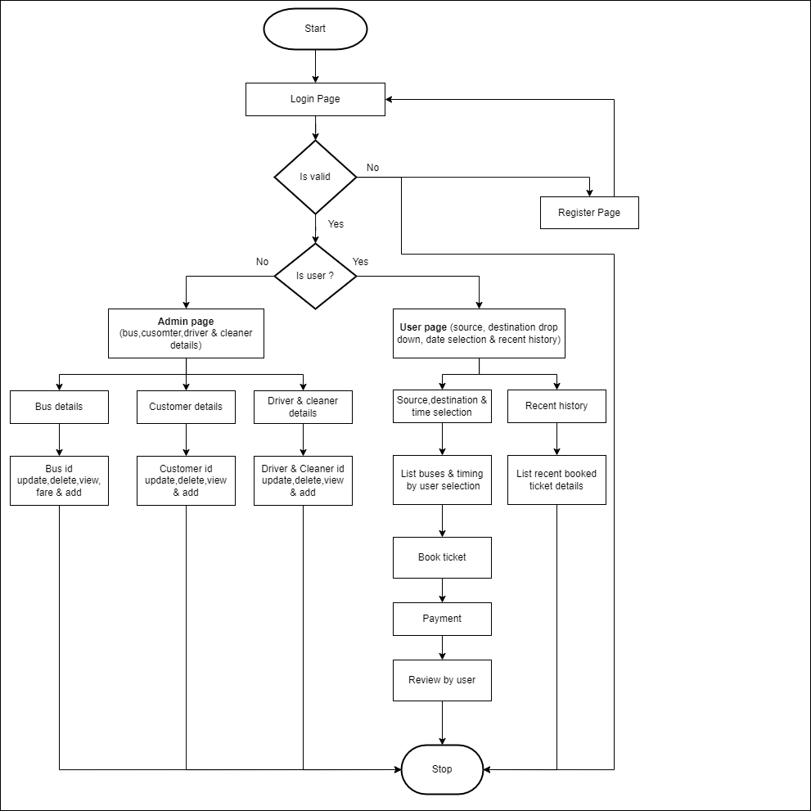

**UML DIAGRAM:**

**CLASS DIAGRAM:**

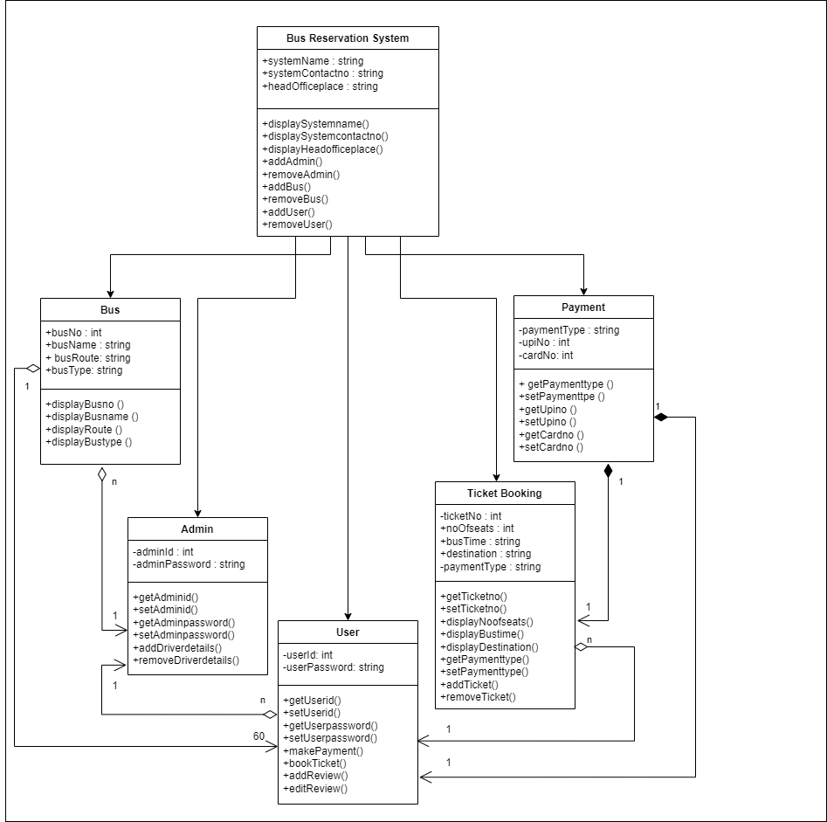

**USECASE DIAGRAM:**

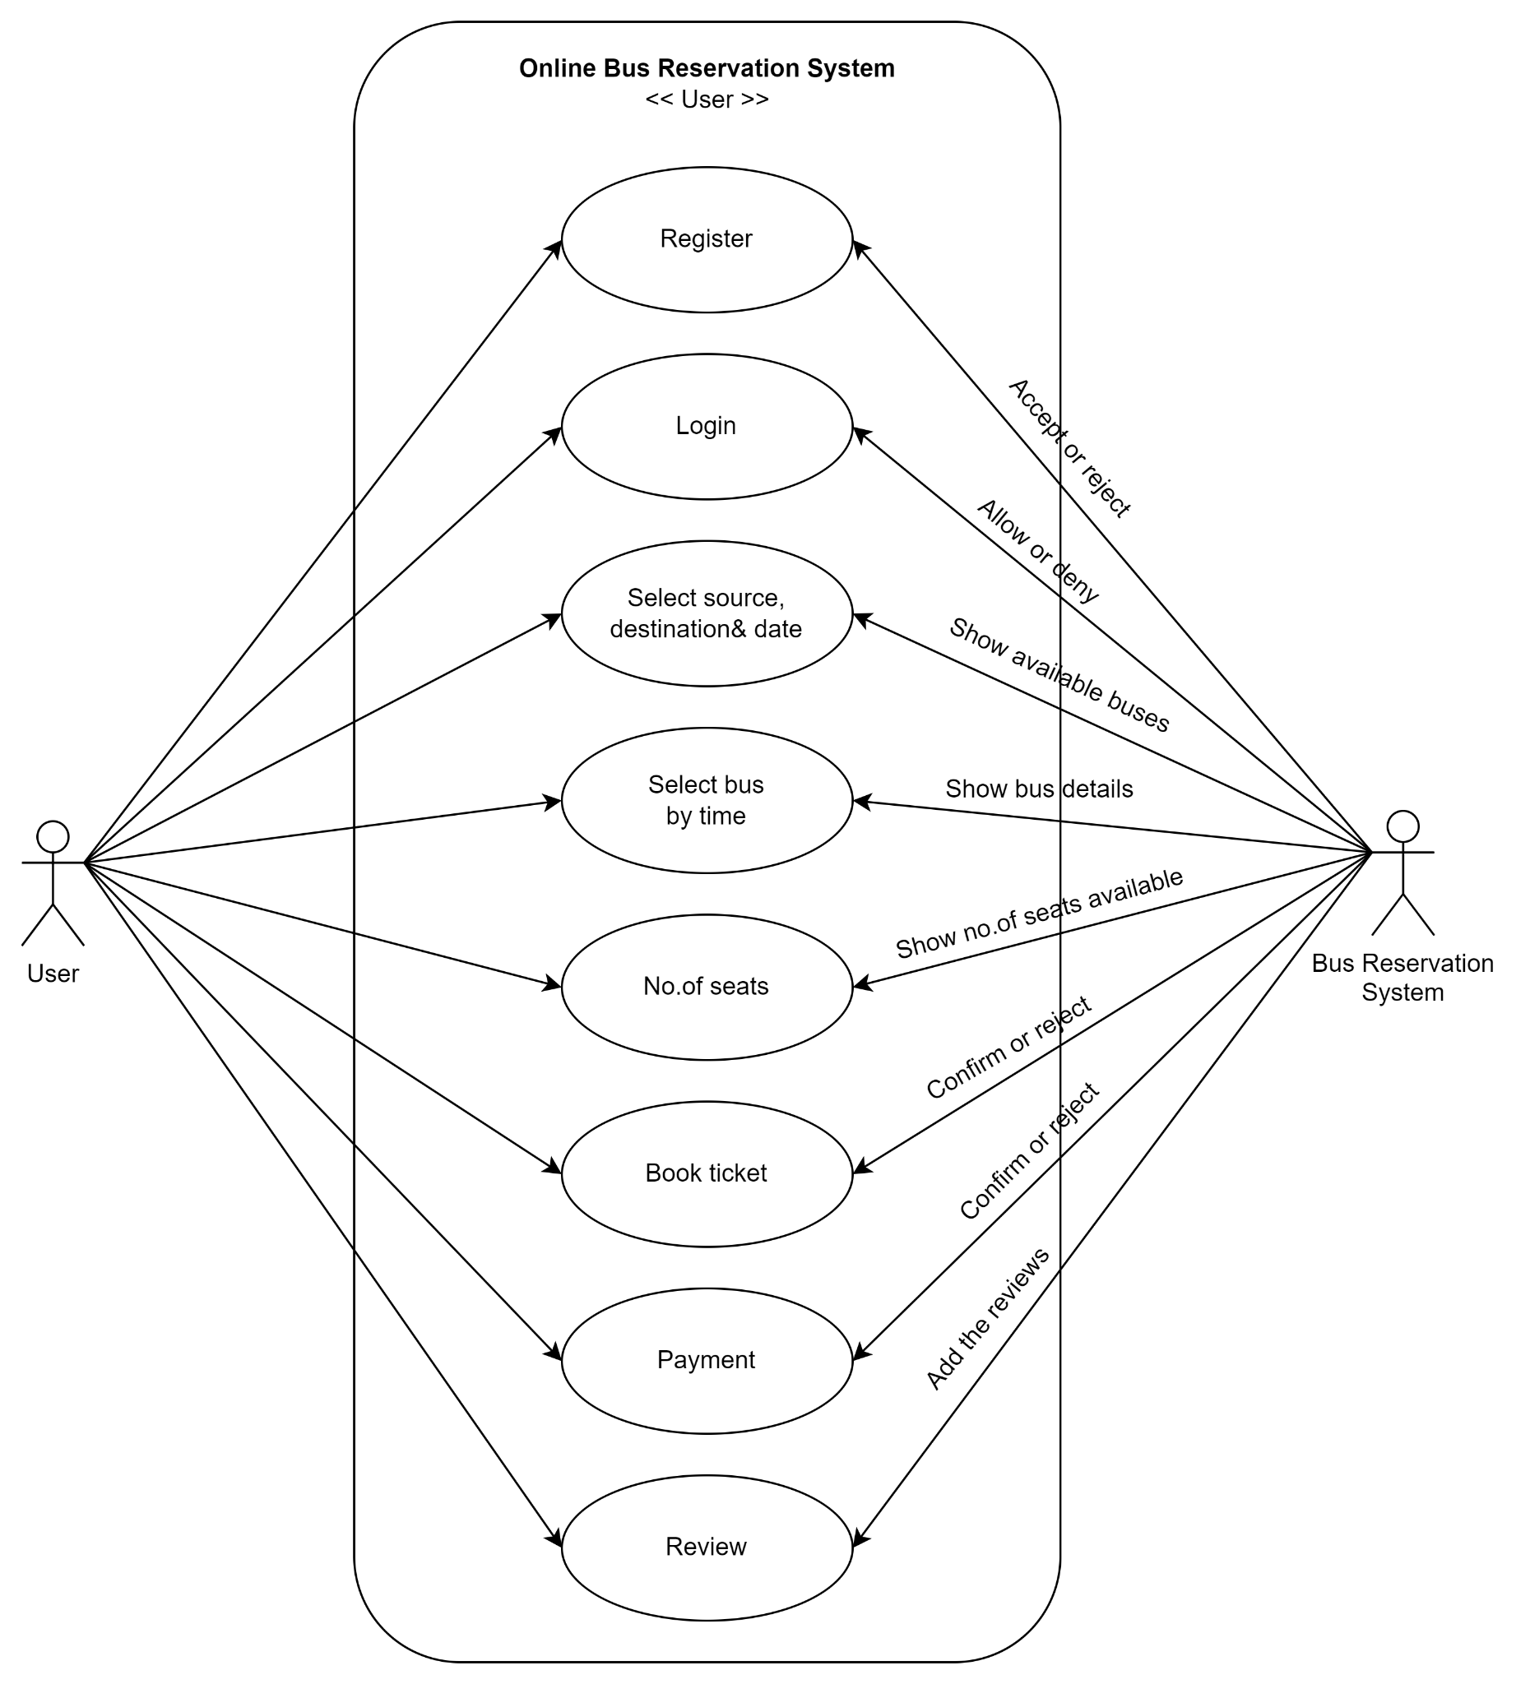

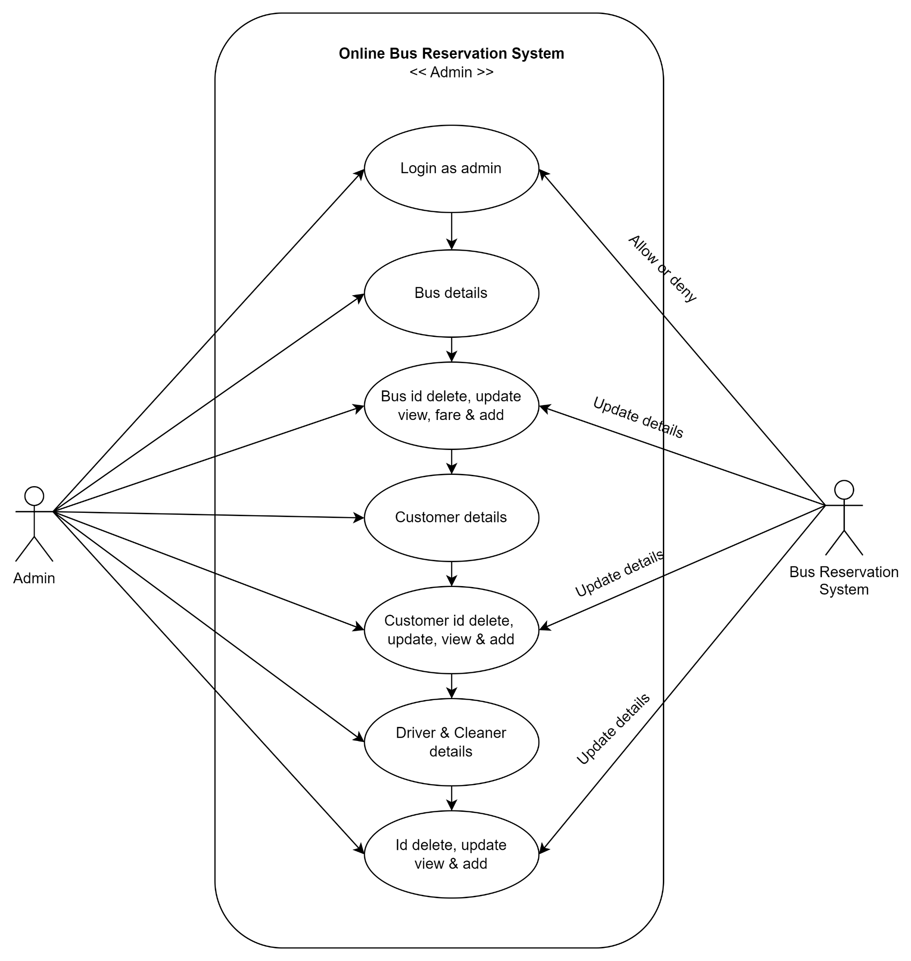

**SEQUENCE DIAGRAM:**

